Organization Chart
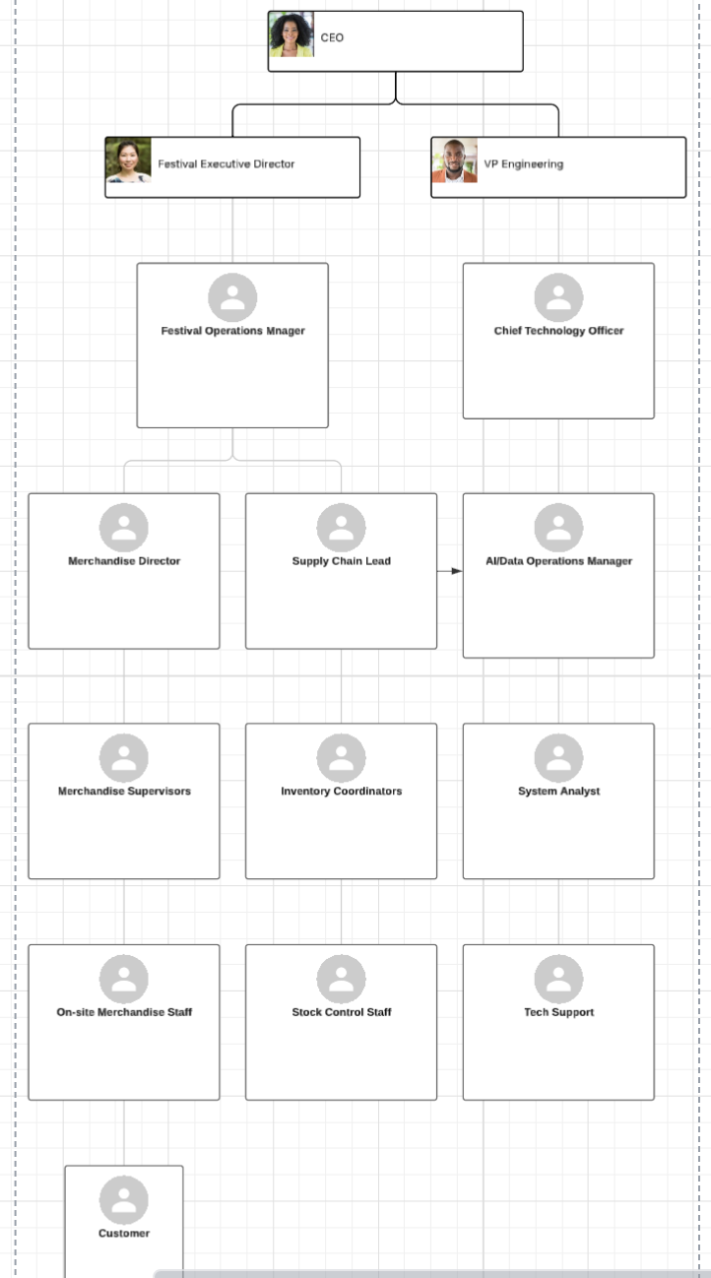
The following chart focuses specifically on the organizational structure supporting the SmartMerch AI app operations during the festival and supports the festival’s existing structure. At the top, executive leadership, including the CEO, Festival Executive Director, and VP of Engineering, provides strategic oversight and ensures the project aligns with overall event goals. Below them, the Festival Operations Manager and Chief Technology Officer bridge operations and technology, coordinating between logistical planning and the integration of AI systems. Mid-level management roles such as the Merchandise Director, Supply Chain Lead, and AI/Data Operations Manager ensure the system functions efficiently by aligning real-time data with inventory and staffing decisions. Supporting teams, including Merchandise Supervisors, Inventory Coordinators, System Analysts, and Tech Support handle daily operations, system monitoring, and on-site troubleshooting to provide an exceptional customer experience. At the ground level, on-site merchandise and stock control staff interact directly with the AI system and customers, maintaining product availability and smooth order fulfillment. Together, this structure demonstrates a streamlined, collaborative workflow where leadership, technology, and on-site teams work in sync to deliver a responsive, data-driven merchandise experience for festival attendees.

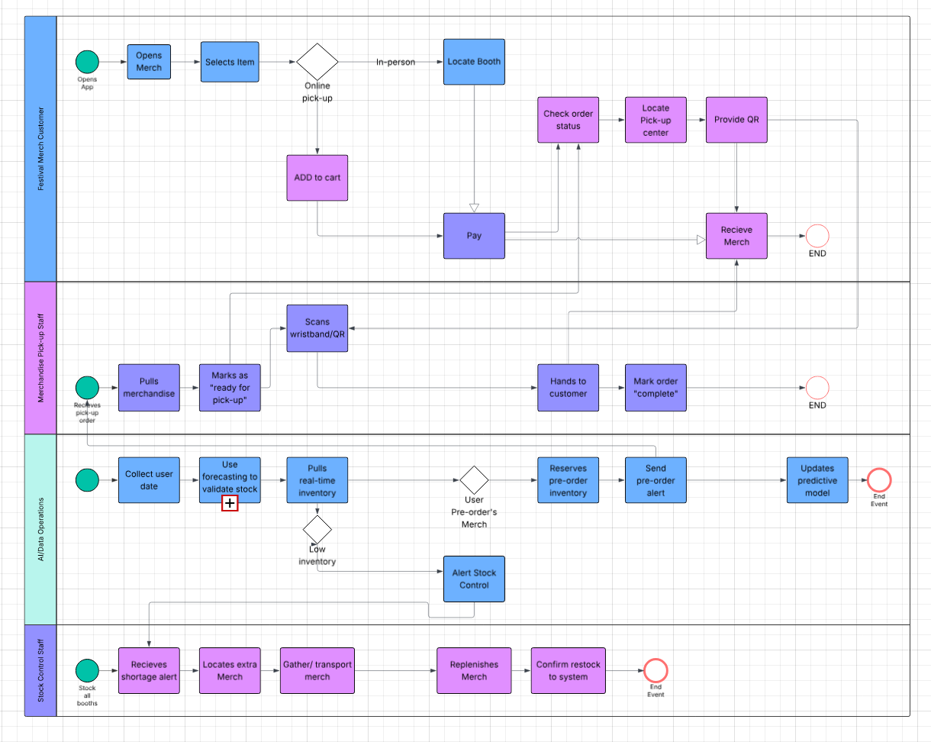
In the top swimlane, the Festival Merch Customer initiates the process by opening the app, browsing merchandise, and selecting an item. A decision gateway splits the path into two options: online pickup or in-person walk-up purchase. For app-assisted walk-up purchases, the customer is directed to the booth with available inventory and completes an in-person payment. For online pickup orders, the user adds the item to the cart, pays through the app, receives confirmation, and then views updates while locating the designated pickup center. Upon arrival, the customer provides their QR code, and the merchandise staff scans and verifies the order before handing the item to the customer and marking the order as complete.
Supporting this customer experience, the BPMN models three additional operational swim lanes. Merchandise Pick-Up Staff receive digital order alerts, pull merchandise from storage, prepare pickup orders, and finalize them once the customer arrives. Meanwhile, the AI/Data Operations lane continuously collects user data, validates inventory using forecasting models, pulls real-time stock information, and determines whether the user’s selected item is available. If it is a pre-order, the system reserves inventory, sends alerts to staff, and updates predictive models based on demand. If inventory is low, the system triggers an alert to the Stock Control Staff, who locate extra merchandise, transport it from storage, replenish booth inventory, and confirm restock in the system.
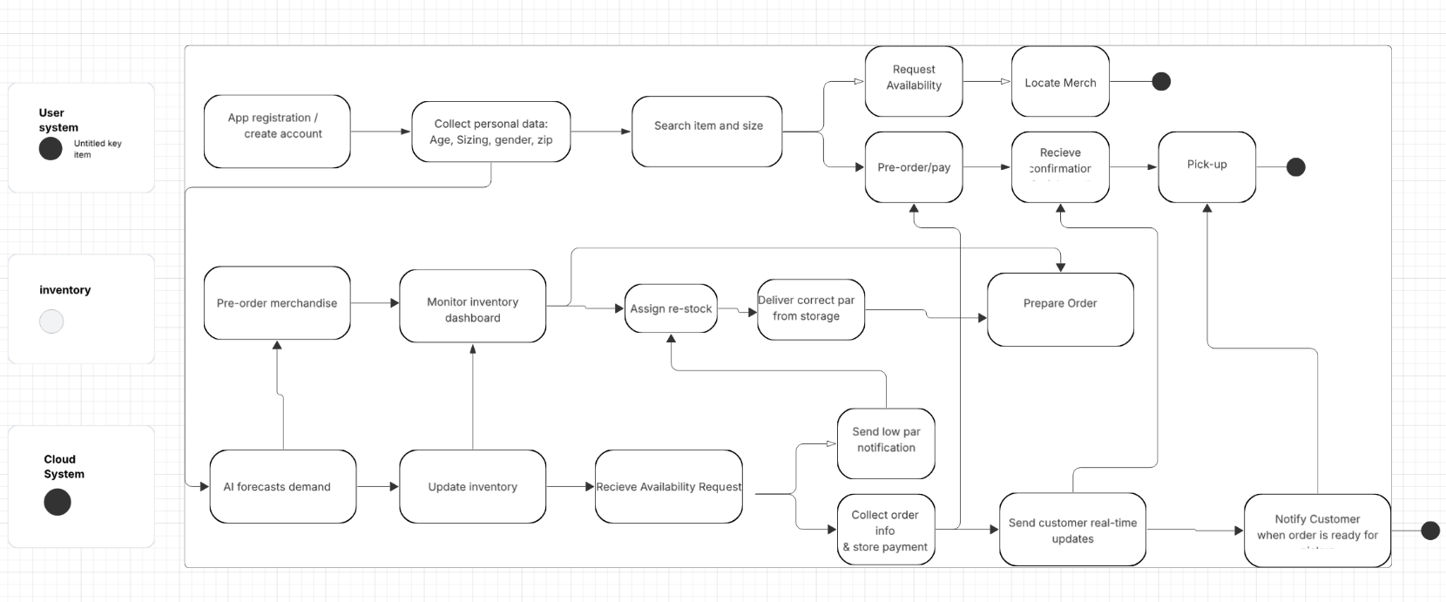
The activity flow chart illustrates the end-to-end operations of the SmartMerch system, beginning with the user’s interaction in the mobile app and extending through inventory management, order processing, and final pick-up. The process starts when a user registers or logs into the app, after which personal data such as age, sizing preferences, gender, and ZIP code is collected to support personalized recommendations and more accurate demand forecasting. The user then searches for an item and size, triggering the system to request real-time availability. Based on this information, the app displays merchandise location for walk-up purchases or allows the user to place a pre-order and pay through the system. Once a purchase is completed, the customer receives an order confirmation and real-time updates. When the order is ready, the system notifies the user to proceed to the designated pick-up location.
Behind the scenes, the cloud-based SmartMerch system integrates AI forecasting, live inventory monitoring, and restocking operations. As the AI engine analyzes user behavior and ongoing sales data, it forecasts demand and updates inventory levels accordingly. Low-par notifications trigger restocking workflows, where inventory teams assign replenishment tasks and deliver items from storage to the appropriate booth. Inventory dashboards continuously support this decision-making cycle by displaying stock statuses and informing restock assignments. When a pre-order is placed, the system forwards the order details to the fulfillment team, who prepare the merchandise and confirm completion in the app. This seamless activity flow ensures accurate stock visibility, efficient on-site operations, and a smooth customer experience from item discovery to final order pick-up.
Our proposed system builds on Coachella’s interactive map as the foundation for the app’s UX/UI design.
Before the event, users are required to register their wristband, which links their profile to key demographic details (including optional sizing information) to improve personalized experiences and future stock analytics.
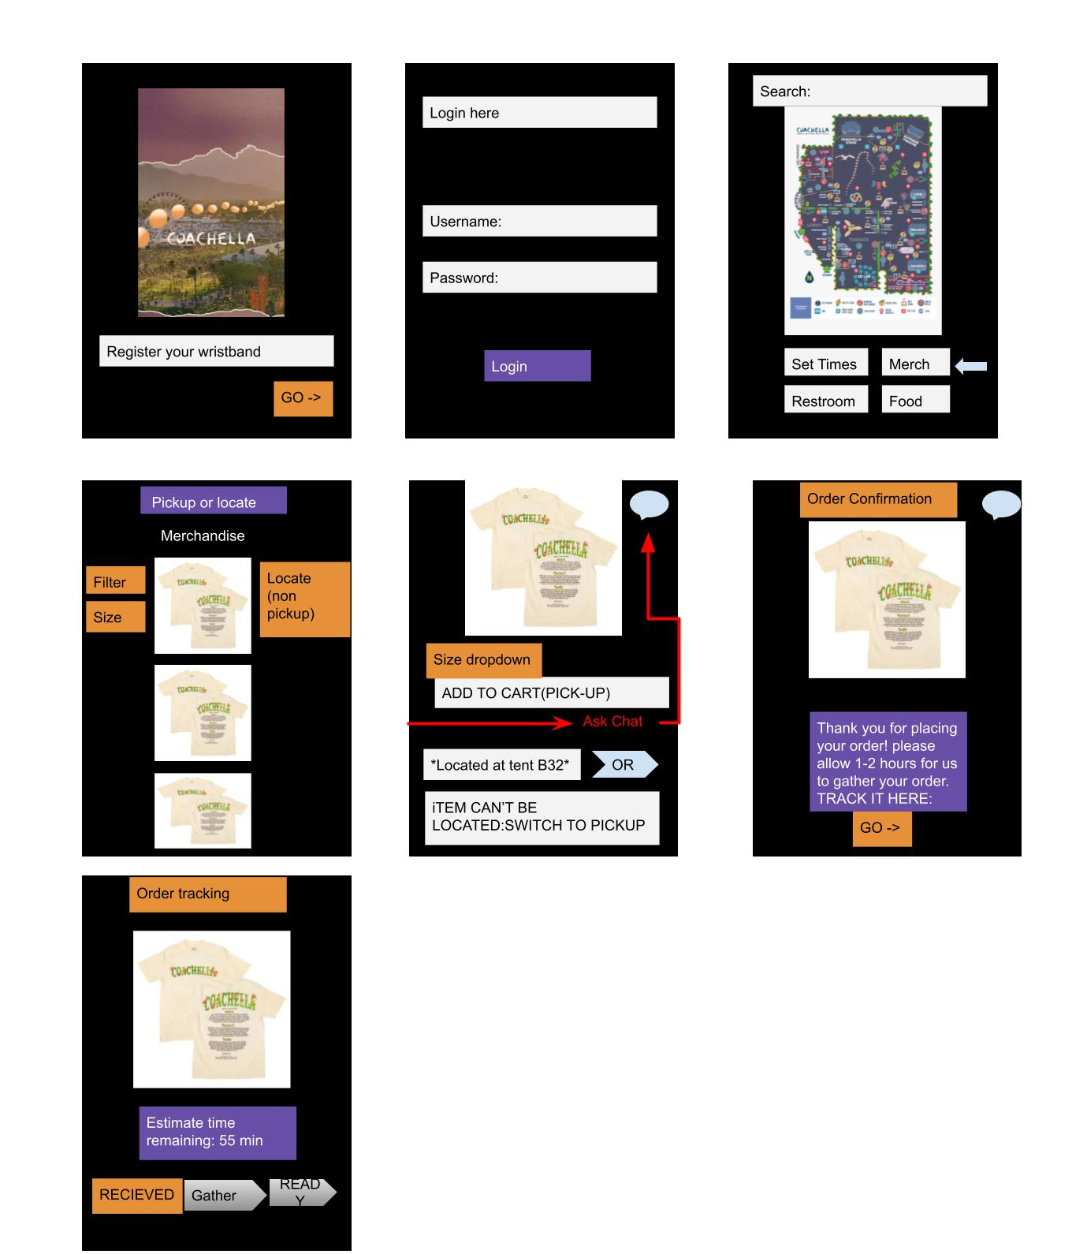
Once signed in, attendees can select “Merch” within the app. The system will automatically display real-time product availability, pre-filtered to the user’s registered size. Users can also adjust filters (e.g., size, color, or category) to explore the full range of merchandise options.
After choosing an item, the user can:
- Add it to their cart for pickup, or
- Use the chatbot to ask where the item is immediately available on-site.
The chatbot integrates with the interactive festival map, guiding customers to the nearest booth with available stock, while also answering product questions to create a seamless and intuitive experience. This approach blends a virtual browsing experience with a hands-on, in-person shopping option.
If an item or size is temporarily out of stock, the user can still select “Pick-Up”, allowing the system to reserve and retrieve the item from on-site storage once it becomes available.
After completing their purchase, the app provides real-time order tracking, including status updates and estimated pickup time, ensuring customers can easily manage their purchases during the festival.

